
AMERICAN INTERNATIONAL UNIVERSITY-BANGLADESH (AIUB)
Department of CSE
Computer-Aided Design and Drafting

Section: L
Report No: # 07 (Handwritten)
Name: Khan, Md. Sazzad
Id: 22–49172-3
Supervised by: MD. RAKIBUL ISLAM CHOWDHURY

1.

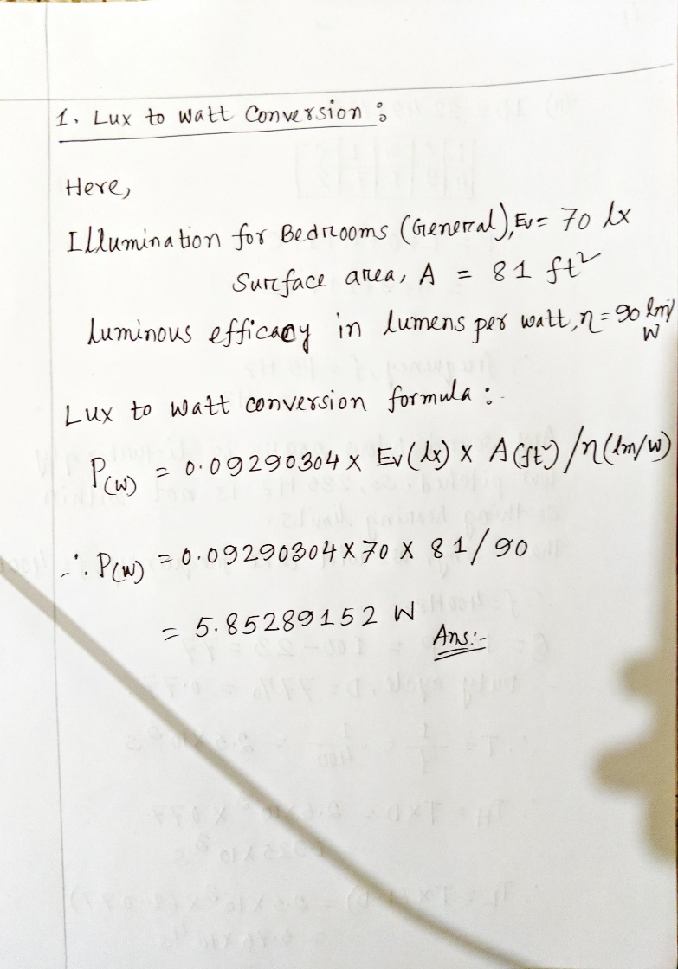

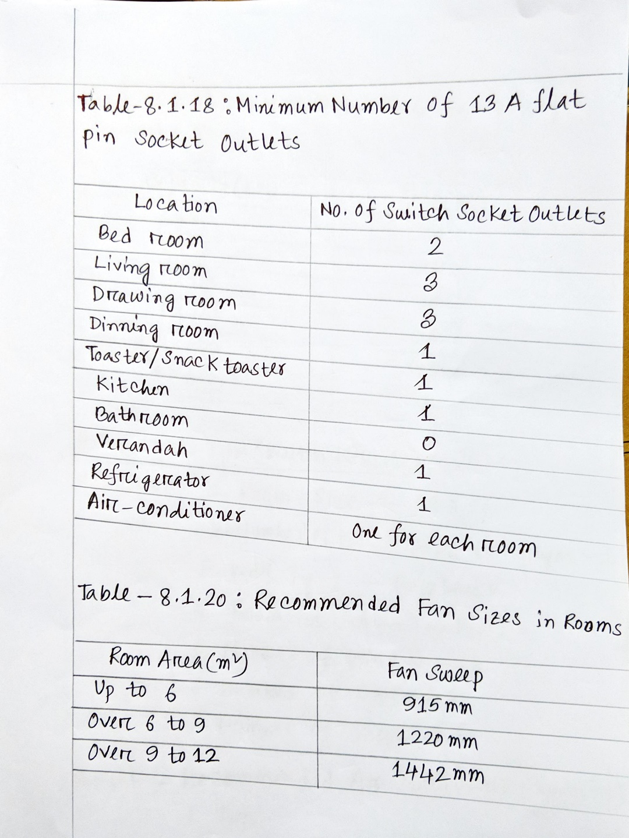
2.

3.
